**Compilation**

jamess-imac:program AcousticTime$ g++ -c Input.cpp

jamess-imac:program AcousticTime$ g++ -c StringToFloat.cpp

jamess-imac:program AcousticTime$ g++ -o program3b program3b.cpp Input.o StringToFloat.o

**Test 1**

jamess-imac:program AcousticTime$ ./program3b

What would you like to do?

Enter 1 to read from file.

Enter 2 to write to file.

Enter 3 to modify a file.

Enter 0 to quit.

Choice: a

Invalid Choice, Try again

What would you like to do?

Enter 1 to read from file.

Enter 2 to write to file.

Enter 3 to modify a file.

Enter 0 to quit.

Choice: 4

Invalid Choice, Try again

What would you like to do?

Enter 1 to read from file.

Enter 2 to write to file.

Enter 3 to modify a file.

Enter 0 to quit.

Choice:

ffadf

Invalid Choice, Try again

What would you like to do?

Enter 1 to read from file.

Enter 2 to write to file.

Enter 3 to modify a file.

Enter 0 to quit.

Choice: 1djfd

Enter the file name to access:

**Test 2**

jamess-imac:program AcousticTime$ ./program3b

What would you like to do?

Enter 1 to read from file.

Enter 2 to write to file.

Enter 3 to modify a file.

Enter 0 to quit.

Choice: 2

Enter the file name to access: test2

Enter the amount of numbers to write: a

Invalid number, Try again

Enter the amount of numbers to write: -1

Invalid number, Try again

Enter the amount of numbers to write: 4

Enter number 1: a

Invalid Value, try again

Enter number 1: dafd

Invalid Value, try again

Enter number 1: 5

Enter number 2:

**Test 3**

jamess-imac:program AcousticTime$ ./program3b

What would you like to do?

Enter 1 to read from file.

Enter 2 to write to file.

Enter 3 to modify a file.

Enter 0 to quit.

Choice: 3

Enter the file name to access: james

What would you like to do with this number, 1?

Enter 1 to accept this number.

Enter 2 to replace this number.

Enter 3 to delete this number.

Enter 4 to insert a new number after current number.

Enter 5 to accept the remainder of the numbers.

Choice: a

Invalid Choice, Try again

What would you like to do with this number, 1?

Enter 1 to accept this number.

Enter 2 to replace this number.

Enter 3 to delete this number.

Enter 4 to insert a new number after current number.

Enter 5 to accept the remainder of the numbers.

Choice: bb

Invalid Choice, Try again

What would you like to do with this number, 1?

Enter 1 to accept this number.

Enter 2 to replace this number.

Enter 3 to delete this number.

Enter 4 to insert a new number after current number.

Enter 5 to accept the remainder of the numbers.

Choice: 7

Invalid Choice, Try again

What would you like to do with this number, 1?

Enter 1 to accept this number.

Enter 2 to replace this number.

Enter 3 to delete this number.

Enter 4 to insert a new number after current number.

Enter 5 to accept the remainder of the numbers.

Choice: 1

What would you like to do with this number, 3?

Enter 1 to accept this number.

Enter 2 to replace this number.

Enter 3 to delete this number.

Enter 4 to insert a new number after current number.

Enter 5 to accept the remainder of the numbers.

Choice:

**UML Class Diagram**

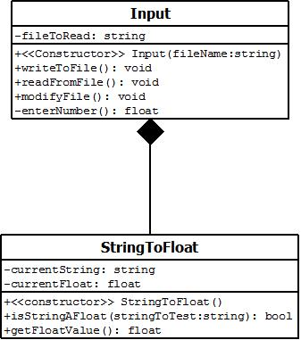

**UML Use Case Diagram**

